EUROPEAN VALUES

- CIVILIAN, MILITARY AND NORMATIVE POWERS OF EUROPE
- EU VALUE MAINSTREAMING.
- EU VALUE STATEMENTS and CHARTER OF FUNDAMENTAL RIGHTS.
- VALUES VS NORMS
- EUROPEAN IDENTITY.
References
Questions for self-reflection
Recommended reading
Case-studies

America's most-trusted online dictionary by Merriam-Webster provides several connotations of the word ‘value’. Value regarded as:
1: ‘the monetary worth of something and in that connotation equals Market Price or
2: a fair return or equivalent in goods, services, or money for something exchanged or
3: relative worth, utility, or importance
4: something (such as a principle or quality) intrinsically valuable or desirable
This part of our course will be, as you understand, not about material values, but about PRINCIPLE THAT INTRINSICALLY VALUABLE OR DESIRABLE in European Union. This part of the course deals with EUROPEAN VALUES and Identity.

1. CIVILIAN, MILITARY AND NORMATIVE POWER OF EUROPE
Researchers distinguish between several types of power: civilian, military and normative power (Manners, 2002; Taylor, 2021). After the Second World War, Europe developed almost exclusively on the concept of civilian power. In his BBC Reith Lectures for 1972, Sir Andrew Shonfield described the European Community as “the purest expression in the international system of what Francois Duchene has called ‘civilian power’, as opposed to traditional military/political power” (Bull, 1982).
Hedley Bull in the early 1980s argued ‘from the perspective of “the return to power politics” of the 1980s’ the civilian power of the EC was conditional upon the military power of states (Bull, 1982; Manners, 2002).
Later on Manners, Ian introduced the idea of normative power in Europe (Manners, 2002). Normative power has many synonyms like ‘power over opinion’, ‘an idée force’, ‘the power of ideas’, ‘ideological power’.
Table 1. Civilian, military and normative powers (Manners, 2002, p. 40)
 | Civilian | Military | Normative
Carr, E.H. (1962) | Economic | Military | Opinion
Galtung, J. (1973) | Remunerative | Punitive | Ideological
(Manners, 2002) | Ability to use  civilian  instruments | Ability to use military instruments | Ability to shape conceptions of ‘normal’

Although normative power is based on civil and military power, it entails also leadership in terms of ideas and the promotion of those ideas worldwide. Value issue fits well into that ‘Ability to shape conceptions of ‘normal’ (Taylor, 2021). Thus, European values are a way of convincing others that what they postulate is the only "normal" state of affairs. This is, if you will, an ideological lens through which an ordinary European look at the world. Moreover, if you look at the world through this ideological lens, as we will see later, you are automatically considered a European by IDENTITY.
2. EU VALUE MAINSTREAMING.
European values are there not to be kept behind the window, moreover, they are DESIGNED to put them into practice. In other words, values are not a high theory to be memorized and then forgotten. THEY ARE FOR DAILY USE. In order to achieve this practical use, the EU uses the so-called EU VALUE MAINSTREAMING tactics. EU VALUE MAINSTREAMING means that values are incorporated in all policies at all levels and at all stages (Taylor, 2021).
The most pertinent mechanism to EU value mainstreaming through bilateral dialogues, procedural diffusion, merely captures the role of institutionalised relationships as a channel for diffusion (Taylor, 2021)(Manners 2002, p. 244).
Analysis of EU’s official discourse in this area testifies to that (Table 2).
Table 2. Analysis of EU’s official discourse in this area
Document | Excerption from document
The Lisbon Treaty (2009) Article 21.1 (Title V) | states that the EU’s external action will be ‘guided by the principles which have inspired its own creation, development, and enlargement, and which it seeks to advance in the wider world [before specifying the EU’s founding values]’ EU (2010), p.28
Strategic Framework and Action Plan for Human Rights and Democracy (2012) | States that ‘the EU will promote human rights in ALL areas of its external action without exception’  (EU Council 2012, p. 2)
EU’s Global Strategy (2016) | that ‘we must… systematically mainstream human rights …across policy sectors and institutions’ (EU 2016,p. 11)
EU Annual Report on Human Rights and Democracy in the World 2016 | States that ‘human rights issues should not be confined to human rights dialogues … [but] included in the agenda of other meetings, including political or other dialogues’  (EU Council 2017, p. 7)

The Lisbon Treaty (2009) Article 21.1 (Title V) postulates that the EU’s external action will be ‘guided by the principles which have inspired its own creation, development, and enlargement, and which it seeks to advance in the wider world (EU 2010, p.28).
These words alone can be interpreted literally and rigidly (a hard interpretation) and figuratively, softly (a soft interpretation) (Figure 1).
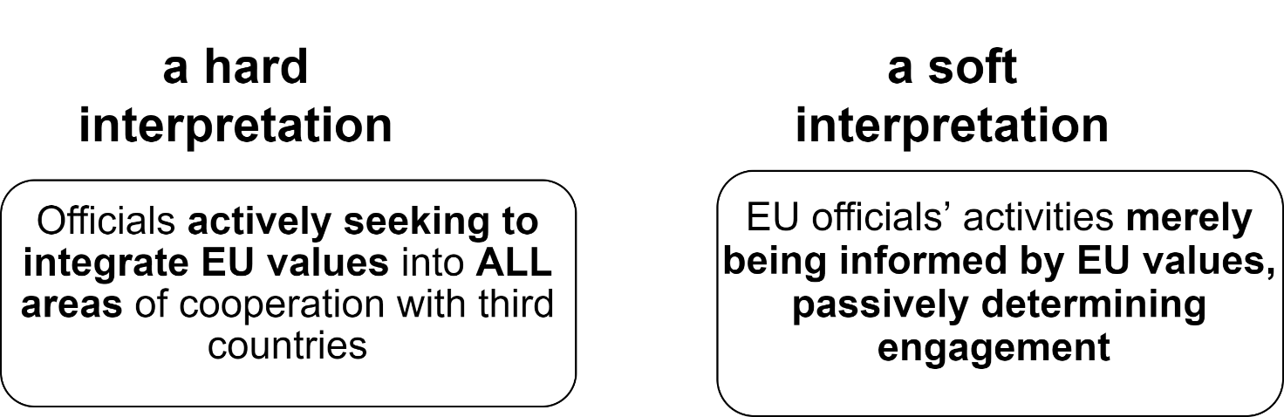
Figure 1. Possible interpretations of the statement of the Lisbon Treaty on values.
At the same time, the other documents listed in Table 1 do not leave any doubt that the EU interprets the Lisbon Treaty through a hard interpretation approach.
Therefore, the documents explicitly suggest that EU officials have a responsibility to actively mainstream human rights into all dialogues with third countries, irrespective of sectoral substance. (Taylor, 2021)
Thus, the EU’s official discourse in this area can therefore “be characterised as systematic value mainstreaming in all dialogues with third countries” (Taylor, 2021)
‘Following this analysis, EU value mainstreaming in dialogues with third countries can be defined as active and focused actions throughout every stage of the process to systematically promote values in all dialogues with third countries (Taylor, 2021)
3. EU VALUE STATEMENTS AND CHARTER OF FUNDAMENTAL RIGHTS
The European Union’s fundamental values are:
- respect for human dignity and human rights,
- freedom,
- democracy,
- equality and
- the rule of law.
These values unite all the member states – no country that does not recognise these values can belong to the Union. All these fundamental values are defined in the Treaty of Lisbon (2009) (Table 3).
Table 3. Fundamental Rights of the European Union (EU Council, 2010, p. 382-402)
DIGNITY | Human dignity | Human dignity is inviolable. It must be respected and protected.
 | Right to life | 1. Everyone has the right to life.  2. No one shall be condemned to the death penalty, or executed
 | Right to the integrity of the person | 1. Everyone has the right to respect for his or her physical and mental integrity.  2. In the fields of medicine and biology, the following must be respected in particular:  (a) the free and informed consent of the person concerned, according to the procedures laid down by law;  (b) the prohibition of eugenic practices, in particular those aiming at the selection of persons;  (c) the prohibition on making the human body and its parts as such a source of financial gain;  (d) the prohibition of the reproductive cloning of human beings.
 | Prohibition of torture and inhuman or degrading treatment or punishment | No one shall be subjected to torture or to inhuman or degrading treatment or punishment.
 | Prohibition of slavery and forced labour | 1. No one shall be held in slavery or servitude.  2. No one shall be required to perform forced or compulsory labour.  3. Trafficking in human beings is prohibited.
FREEDOMS | Right to liberty and security | Everyone has the right to liberty and security of person.
 | Respect for private and family life | Everyone has the right to respect for his or her private and family life, home and communications.
 | Protection of personal data | 1. Everyone has the right to the protection of personal data concerning him or her.  2. Such data must be processed fairly for specified purposes and on the basis of the consent of the person concerned or some other legitimate basis laid down by law. Everyone has the right of access to data which has been collected concerning him or her, and the right to have it rectified.  3. Compliance with these rules shall be subject to control by an independent authority.
 | Right to marry and right to found a family | The right to marry and the right to found a family shall be guaranteed in accordance with the national laws governing the exercise of these rights.
 | Freedom of thought, conscience and religion | 1. Everyone has the right to freedom of thought, conscience and religion. This right includes freedom to change religion or belief and freedom, either alone or in community with others and in public or in private, to manifest religion or belief, in worship, teaching, practice and observance.  2. The right to conscientious objection is recognised, in accordance with the national laws governing the exercise of this right.
 | Freedom of expression and information | 1. Everyone has the right to freedom of expression. This right shall include freedom to hold opinions and to receive and impart information and ideas without interference by public authority and regardless of frontiers.  2. The freedom and pluralism of the media shall be respected.
 | Freedom of assembly and of association | 1. Everyone has the right to freedom of peaceful assembly and to freedom of association at all levels, in particular in political, trade union and civic matters, which implies the right of everyone to form and to join trade unions for the protection of his or her interests.  2. Political parties at Union level contribute to expressing the political will of the citizens of the Union.
 | Freedom of the arts and sciences | The arts and scientific research shall be free of constraint. Academic freedom shall be respected.
 | Right to education | 1. Everyone has the right to education and to have access to vocational and continuing training.  2. This right includes the possibility to receive free compulsory education.  3. The freedom to found educational establishments with due respect for democratic principles and the right of parents to ensure the education and teaching of their children in conformity with their religious, philosophical and pedagogical convictions shall be respected, in accordance with the national laws governing the exercise of such freedom and right.
 | Freedom to choose an occupation and right to engage in work | 1. Everyone has the right to engage in work and to pursue a freely chosen or accepted occupation.  2. Every citizen of the Union has the freedom to seek employment, to work, to exercise the right of establishment and to provide services in any Member State.  3. Nationals of third countries who are authorised to work in the territories of the Member States are entitled to working conditions equivalent to those of citizens of the Union.
 | Freedom to conduct a business | The freedom to conduct a business in accordance with Union law and national laws and practices is recognised.
 | Right to property | 1. Everyone has the right to own, use, dispose of and bequeath his or her lawfully acquired possessions. No one may be deprived of his or her possessions, except in the public interest and in the cases and under the conditions provided for by law, subject to fair compensation being paid in good time for their loss. The use of property may be regulated by law in so far as is necessary for the general interest.  2. Intellectual property shall be protected.
 | Right to asylum | The right to asylum shall be guaranteed with due respect for the rules of the Geneva Convention of 28 July 1951 and the Protocol of 31 January 1967 relating to the status of refugees and in accordance with the Treaty on European Union and the Treaty on the Functioning of the European Union (hereinafter referred to as ‘the Treaties’).
 | Protection in the event of removal, expulsion or extradition | 1. Collective expulsions are prohibited.  2. No one may be removed, expelled or extradited to a State where there is a serious risk that he or she would be subjected to the death penalty, torture or other inhuman or degrading treatment or punishment.
EQUALITY | Equality before the law | Everyone is equal before the law.
 | Non-discrimination | 1. Any discrimination based on any ground such as sex, race, colour, ethnic or social origin, genetic features, language, religion or belief, political or any other opinion, membership of a national minority, property, birth, disability, age or sexual orientation shall be prohibited.  2. Within the scope of application of the Treaties and without prejudice to any of their specific provisions, any discrimination on grounds of nationality shall be prohibited.
 | Cultural, religious and linguistic diversity | The Union shall respect cultural, religious and linguistic diversity.
 | Equality between women and men | Equality between women and men must be ensured in all areas, including employment, work and pay.  The principle of equality shall not prevent the maintenance or adoption of measures providing for specific advantages in favour of the under-represented sex.
 | The rights of the child | 1. Children shall have the right to such protection and care as is necessary for their well-being. They may express their views freely. Such views shall be taken into consideration on matters which concern them in accordance with their age and maturity.  2. In all actions relating to children, whether taken by public authorities or private institutions, the child's best interests must be a primary consideration.  3. Every child shall have the right to maintain on a regular basis a personal relationship and direct contact with both his or her parents, unless that is contrary to his or her interests.
 | The rights of the elderly | The Union recognises and respects the rights of the elderly to lead a life of dignity and independence and to participate in social and cultural life.
 | Integration of persons with disabilities | The Union recognises and respects the right of persons with disabilities to benefit from measures designed to ensure their independence, social and occupational integration and participation in the life of the community.
SOLIDARITY | Workers' right to information and consultation within the undertaking | Workers or their representatives must, at the appropriate levels, be guaranteed information and consultation in good time in the cases and under the conditions provided for by Union law and national laws and practices.
 | Right of collective bargaining and action | Workers and employers, or their respective organisations, have, in accordance with Union law and national laws and practices, the right to negotiate and conclude collective agreements at the appropriate levels and, in cases of conflicts of interest, to take collective action to defend their interests, including strike action.
 | Right of access to placement services | Everyone has the right of access to a free placement service.
 | Protection in the event of unjustified dismissal | Every worker has the right to protection against unjustified dismissal, in accordance with Union law and national laws and practices.
 | Fair and just working conditions | 1. Every worker has the right to working conditions which respect his or her health, safety and dignity.  2. Every worker has the right to limitation of maximum working hours, to daily and weekly rest periods and to an annual period of paid leave.
 | Prohibition of child labour and protection of young people at work | The employment of children is prohibited. The minimum age of admission to employment may not be lower than the minimum school-leaving age, without prejudice to such rules as may be more favourable to young people and except for limited derogations.  Young people admitted to work must have working conditions appropriate to their age and be protected against economic exploitation and any work likely to harm their safety, health or physical, mental, moral or social development or to interfere with their education.
 | Family and professional life | 1. The family shall enjoy legal, economic and social protection.  2. To reconcile family and professional life, everyone shall have the right to protection from dismissal for a reason connected with maternity and the right to paid maternity leave and to parental leave following the birth or adoption of a child.
 | Social security and social assistance | 1. The Union recognises and respects the entitlement to social security benefits and social services providing protection in cases such as maternity, illness, industrial accidents, dependency or old age, and in the case of loss of employment, in accordance with the rules laid down by Union law and national laws and practices.  2. Everyone residing and moving legally within the European Union is entitled to social security benefits and social advantages in accordance with Union law and national laws and practices.  3. In order to combat social exclusion and poverty, the Union recognises and respects the right to social and housing assistance so as to ensure a decent existence for all those who lack sufficient resources, in accordance with the rules laid down by Union law and national laws and practices.
 | Health care | Everyone has the right of access to preventive health care and the right to benefit from medical treatment under the conditions established by national laws and practices. A high level of human health protection shall be ensured in the definition and implementation of all the Union's policies and activities.
 | Access to services of general economic interest | The Union recognises and respects access to services of general economic interest as provided for in national laws and practices, in accordance with the Treaties, in order to promote the social and territorial cohesion of the Union.
 | Environmental protection | A high level of environmental protection and the improvement of the quality of the environment must be integrated into the policies of the Union and ensured in accordance with the principle of sustainable development.
 | Consumer protection | Union policies shall ensure a high level of consumer protection.
CITIZENS' RIGHTS | Right to vote and to stand as a candidate at elections to the European Parliament | 1. Every citizen of the Union has the right to vote and to stand as a candidate at elections to the European Parliament in the Member State in which he or she resides, under the same conditions as nationals of that State.  2. Members of the European Parliament shall be elected by direct universal suffrage in a free and secret ballot.
 | Right to vote and to stand as a candidate at municipal elections | Every citizen of the Union has the right to vote and to stand as a candidate at municipal elections in the Member State in which he or she resides under the same conditions as nationals of that State.
 | Right to good administration | 1. Every person has the right to have his or her affairs handled impartially, fairly and within a reasonable time by the institutions, bodies, offices and agencies of the Union.  2. This right includes:  (a) the right of every person to be heard, before any individual measure which would affect him or her adversely is taken;  (b) the right of every person to have access to his or her file, while respecting the legitimate interests of confidentiality and of professional and business secrecy;  (c) the obligation of the administration to give reasons for its decisions.  3. Every person has the right to have the Union make good any damage caused by its institutions or by its servants in the performance of their duties, in accordance with the general principles common to the laws of the Member States.  4. Every person may write to the institutions of the Union in one of the languages of the Treaties and must have an answer in the same language.
 | Right of access to documents | Any citizen of the Union, and any natural or legal person residing or having its registered office in a Member State, has a right of access to documents of the institutions, bodies, offices and agencies of the Union, whatever their medium.
 | European Ombudsman | Any citizen of the Union and any natural or legal person residing or having its registered office in a Member State has the right to refer to the European Ombudsman cases of maladministration in the activities of the institutions, bodies, offices or agencies of the Union, with the exception of the Court of Justice of the European Union acting in its judicial role.
 | Right to petition | Any citizen of the Union and any natural or legal person residing or having its registered office in a Member State has the right to petition the European Parliament.
 | Freedom of movement and of residence | 1. Every citizen of the Union has the right to move and reside freely within the territory of the Member States.  2. Freedom of movement and residence may be granted, in accordance with the Treaties, to nationals of third countries legally resident in the territory of a Member State.
 | Diplomatic and consular protection | Every citizen of the Union shall, in the territory of a third country in which the Member State of which he or she is a national is not represented, be entitled to protection by the diplomatic or consular authorities of any Member State, on the same conditions as the nationals of that Member State.
JUSTICE | Right to an effective remedy and to a fair trial | Everyone whose rights and freedoms guaranteed by the law of the Union are violated has the right to an effective remedy before a tribunal in compliance with the conditions laid down in this Article.  Everyone is entitled to a fair and public hearing within a reasonable time by an independent and impartial tribunal previously established by law. Everyone shall have the possibility of being advised, defended and represented. Legal aid shall be made available to those who lack sufficient resources in so far as such aid is necessary to ensure effective access to justice.
 | Presumption of innocence and right of defence | 1. Everyone who has been charged shall be presumed innocent until proved guilty according to law.  2. Respect for the rights of the defence of anyone who has been charged shall be guaranteed.
 | Principles of legality and proportionality of criminal offences and penalties | 1. No one shall be held guilty of any criminal offence on account of any act or omission which did not constitute a criminal offence under national law or international law at the time when it was committed. Nor shall a heavier penalty be imposed than the one that was applicable at the time the criminal offence was committed. If, subsequent to the commission of a criminal offence, the law provides for a lighter penalty, that penalty shall be applicable.  2. This Article shall not prejudice the trial and punishment of any person for any act or omission which, at the time when it was committed, was criminal according to the general principles recognised by the community of nations.  3. The severity of penalties must not be disproportionate to the criminal offence.
 | Right not to be tried or punished twice in criminal proceedings for the same criminal offence | No one shall be liable to be tried or punished again in criminal proceedings for an offence for which he or she has already been finally acquitted or convicted within the Union in accordance with the law.

“The EU values are common to the EU countries
in a society in which inclusion, tolerance,
justice, solidarity and non-discrimination prevail.
These values are an integral part of our European way of life”.
European Commission https://ec.europa.eu/component-library/eu/about/eu-values/

4. VALUES VS NORMS
The EU is based on five principles that have fundamental to the cooperation of all 27 in many respects different states. These are 1) common values, 2) supranationality, 3) degressive proportionality, 4) solidarity and 5) subsidiarity.
As you can see, common values are the first at the list of principles. In this module you will learn about European values as a fundamental principle of the EU. values set out in Article 2 of the “Treaty of the European Union”. The promotion of values is presented as part of “the fight against the rise of populism, xenophobia, divisive nationalism and the spreading of fake news”. There are many challenges for European community today. “Declaration on promoting citizenship and the common values of freedom, tolerance and nondiscrimination through education” was issued in March 2015 by the EU Ministers of Education as a response to the terrorist attacks on Charlie Hebdo. These recent initiatives reveal how EU institutional actors invoke and reassert common values in reaction to the major threats currently affecting European democracy. This is an illustration of the trend that, since the beginning of the twenty-first century, has seen “values” dramatically re-emerge in the political life of Western democracies. European multi-level governance, both in national, transnational, and supranational levels, makes no exception. In the European Union (EU), the enlargements, the geopolitical challenges and the economic crises have triggered debates on the common values susceptible to hold member states and citizens together, to justify public action and to ensure the sustainability of the European political, economic, and social models.
Studying values, it is important to understand the differences between values and norms. Even when discussing European values, misunderstandings often occur when talking about values and norms or standards.
Values are general ideals. As Paula Surridge said: “They are not beliefs about what is but rather desires about what ought to be – not a diagnosis of society’s ills but rather a picture of what a healthy society should look like. Values are ‘enduring’: they are more permanent than attitudes, more akin to broad musical tastes than to a like or dislike of a particular piece of music; they are ‘latent’, they cannot be directly measured by simply asking people what values they hold”.
Values are deep meaningful orientations of an individual or group of people. Values are important elements of internal personality structures, fixed by a person's experience. They separate important things from the insignificant to a person. Values underlie norms, which are action-guiding rules. There are three kinds of such rules: permissions, orders or commands and prohibitions. Values show what persons and communities hold as important. Norms say what has to be done in order to realize values. Without a reference to underlying values, rules lack motivation and justification. Without corresponding norms, values lack specification and concrete direction. Brexit, British politics and values.
Values define goals and beliefs and can be embodied in socio-political movements and institutions. For example, fundamental human rights are embodied in the constitutions of European countries, in the system of separation of legislative, judicial, and executive powers, in such democratic institutions as freedom of speech, organization, free, secret and transparent elections. So, the institutionalization of values means the development of legal mechanisms for the realization of values, as well as institutions, first - the authorities responsible for the implementation and observance of human rights and freedoms. The institutionalization of political rights and freedoms (primarily the right to freedom of expression, the freedom of assembly and association) ensured the participation of citizens in political life.
Values are important beliefs or ideals of a person in a community, serving as a motivation for action. Norms are action-guiding rules. The difference between a value and a norm is that a value is general, referring to an overall ideal, whereas a norm is concrete, specifying certain things that have to be done (or omitted). Values can be operationalized in specifying norms; norms refer to and are justified by underlying values.
Why is it important to distinguish between values and norms? Even when discussing European values, misunderstandings often occur when talking about values and standards, or vice versa. Norms are general rules of daily life that can be enhanced by social sanctions such as social displeasure or ostracism. Norms are depending on the place and the time in which they are valid, they can be incorporated into laws and thus constitute rights. If these laws are violated, there are legal sanctions. In philosophy, values are regarded as universal, situation-independent ideas about what is considered desirable in a society. Values hover over norms and rights. They are the ideal of something that is socially considered ethically desirable and good. They are worth aspiring, but are usually not fully achieved and realized. This is important to be able to answer certain arguments: just because e.g. freedom or equality in reality may not be fully implemented, this does not mean that these values as such are pointless and must be rejected.
The common values of the European Union are fixed in Article 6 paragraph 1 of the Treaty on the European Union.
Cultural rights and freedoms: this is the fourth generation of rights and freedoms has implemented in European countries since the end of the XX century. The multicultural nature of modern European society requires special attention to ensuring equal rights and freedoms for different national, linguistic and religious minorities and to preventing discrimination. The European Charter for Regional or Minority Languages (10) (adopted by the Council of Europe on 5 November 1992) and the Framework Convention for the Protection of National Minorities, adopted by the Council of Europe, are dedicated to these issues. These documents have become the recommendations and values of the united Europe appeals to all member states of the Council of Europe to implement the following measures:
- prohibition of discrimination on the grounds of language, culture, nationality and gender;
- Prohibition of the policy of assimilation of minorities, ie prevention of forcible imposition of a certain culture, religion, language and gender orientation;
- developing conditions for preserving cultural identity of immigrants and national minorities;
- ensuring the rights of minorities to freedom of assembly, association, speech and religion.
Particular attention in these documents is paid to the prohibition of discrimination against members of national, ethnic and linguistic minorities of migrants in the exercise of fundamental, political and social rights and freedoms. Discrimination means restricting or denying these people the same rights and freedoms as the "titular" nation or the cultural and linguistic majority of the population. Thus, the prohibition of discrimination in the exercise of the right to work means that whites and blacks have equal access to jobs. The second important aspect of cultural rights and freedoms is to ensure the rights of various minorities to preserve their cultural identity, i.e., language, lifestyles and cultural traditions, religious beliefs.
The European Charter for Regional or Minority Languages emphasizes the provision of education, or a substantial part of it, in one's mother tongue. Based on the current realities of the multicultural and multinational composition of the EU and EU member states, the Charter recognizes the cultural, religious and linguistic diversity of EU citizens and the right to cultural, linguistic or religious identity and respect for it.
EU values. How do the Europeans perceive them?
This Eurobarometer survey asked citizens among several topics, which political issue the Parliament should deal with as a matter of priority.
Human rights, freedom of speech, gender equality top lists of EU fundamental values.
- 52% consider climate change to be the most current pressing environmental issue
- 59% are in favour of their country being a member of the EU
Parliament’s autumn Eurobarometer survey traditionally asks citizens which political issue the European Parliament should deal with as a matter of priority. With regard to European values, a clear majority of citizens see protecting human rights worldwide (48%), freedom of speech (38%), gender equality (38%) and solidarity between EU member states (33%) as the main fundamental values to preserve in the European Union.
Although the ranking of priorities show a significant variation across individual member states, for the first time climate change tops the list of citizens’ priority issues. Nearly every third respondent (32%) wants Parliament to address combating climate change as its biggest priority. The fight against poverty and social exclusion (31%), combating terrorism (24%) as well as tackling unemployment (24%) follow in the average EU ranking of citizens’ priorities.
Over the course of the past year, mainly youth-led climate protests have mobilised millions of citizens in the EU and around the world. The 2019 Parlemeter data reflects this feeling of climate emergency, as an absolute majority of respondents (52%) consider climate change to currently be the most pressing environmental issue, followed by air pollution (35%), maritime pollution (31%), deforestation (28%) and the growing amount of waste (28%). In addition, nearly six out of ten Europeans believe that these youth-led protests contributed both at European and at national level to more political measures against climate change.
Six in ten Europeans (59%) in favour of their country’s EU membership.
With nearly six in ten Europeans (59%) in favour of their country’s EU membership, citizens’ support for the European Union remains high for the third year in a row, says the European Parliament’s autumn Eurobarometer survey. Conducted in October 2019, results also show an increased level of satisfaction with the way democracy works in the European Union: 52% (+3 pp) of Europeans share this feeling, indicating that the recent European elections and increased voter turnout contributed positively to this.
European citizens would like to see the European Parliament playing a stronger role, with 58% of respondents calling for a more influential Parliament in the future. This is an increase of 7 percentage points since spring 2019 and the highest result for this indicator since 2007.
Large majority wants more information on the EU
Last, but not least, the 2019 Parlemeter offers valuable insight into which kind of EU-related information European citizens would be interested in – and how they might be more engaged with EU policy making. In total, three-quarters of Europeans (77%) would like to receive more information on the activities of the European institutions. The concrete consequences of EU legislation at local, regional and national level as well as the activities of the European Parliament and its Members are among the areas most relevant for citizens.
5. EUROPEAN IDENTITY.
There are several approaches to Identity (Figure 2).
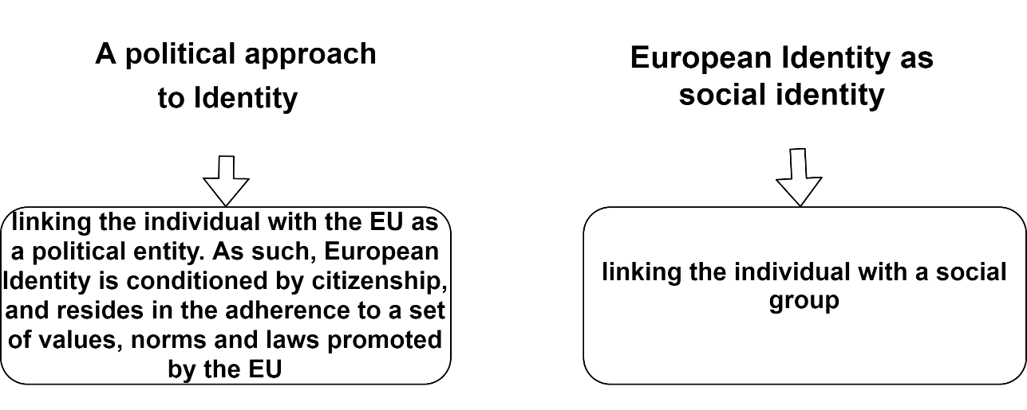
Figure 2. Approaches to European Identity.

There are two broad methods to define European Identity. One approach looks at European Identity as a political one, combining the individual with the EU as a political entity. Thus, such an identity is tied to citizenship and resides in the adherence to a set of values, norms and laws promoted by the EU (Bruter, 2003). Instead, an approach to European Identity as social identity linking the individual with a social group (Voicu & Ramia, 2021).
In the same vein, the literature differentiates between ASCRIBED versus ACHIEVED identity, the first category relying on factors that are assumed at birth and cannot be changed during the life course, such as place of birth, ancestry or common history, while the second considers that identity depends on factors that can be achieved during the life course, such as sharing similar values, norms and laws (Voicu & Ramia, 2021).
There is a consensus though that social and achieved identity outperforms political and ascribed identity: SOCIAL AND ACHIEVED IDENTITY IS MUCH MORE IMPORTANT AND DETERMINES WHO WE ARE.
European Identity resides in the inclusion of the European policy level into the individual social identity (Roose, 2013). Moreover, “Europe is a cultural reality that spreads well beyond the boundaries of the European Union” (Guibernau, 2011).
Furthermore, “European identity relies on the shared consciousness of belonging to an economic and political space defined by capitalism, social welfare, liberal democracy, respect for human rights, freedom and the rule of law, prosperity and progress” (Guibernau, 2011, p. 312).
This is not only the opinion of researchers and bureaucrats because the citizens of Europe and its neighbouring countries think so and testifies to that The European Values Study. The European Values Study is a large-scale, cross-national and longitudinal survey of attitudes, opinions and values. EVS is produced by Tilburg University and partners, using representative national adult population samples and face-to-face interviews.
EVS 2017 included a scale comprising four items to assess the cognitive component of European Identity:
“People differ in what they think it means to be European. In your view, how important is each of the following to be European?
- To be born in Europe/
- To have European ancestry/
- To be a Christian/
- To share European culture”.
The answers were measured on a four-point scale ranging from 1 - very important to 4 - not important at all (Voicu & Ramia, 2021).
EVS 2017 covered EU member states, candidate countries and as well as countries belonging to the Commonwealth of Independent States (CIS) (Voicu & Ramia, 2021).
The results of the questionnaire are presented in Table 4.
Table 4. Items measuring European identity: descriptive statistics (Voicu & Ramia, 2021)
Question wording | Obs | Mean | SD | Min | Max
To be born in Europe | 52,362 | 2.34 | 0.921 | 1 | 4
To have European ancestry | 52,198 | 2.44 | 0.904 | 1 | 4
To be a Christian | 52,047 | 2.79 | 1.002 | 1 | 4
To share European culture | 52,211 | 1.95 | 0.814 | 1 | 4

Thus, over 50,000 respondents from 30 countries from Europe and neighbouring countries distributed what defines European identity in this order:
- To share European culture
- To be born in Europe
- To have European ancestry
- To be a Christian
Thus, adherence and sharing of European culture define you as a European regardless of skin colour, religion, dietary preferences and place of residence (Bréchon & Gonthier, 2017).
So let’s JOIN EUROPE through sharing European values and culture.

REFERENCES
Bréchon, P., & Gonthier, F. (Eds.). (2017). European Values. Trends and Divides Over Thirty Years. BRILL. https://doi.org/10.1163/9789004341067
Bruter, M. (2003). Winning Hearts and Minds for Europe. Comparative Political Studies, 36(10), 1148–1179. https://doi.org/10.1177/0010414003257609
Bull, H. (1982). Civilian Power Europe: A Contradiction in Terms? JCMS: Journal of Common Market Studies, 21(2), 149–170. https://doi.org/10.1111/j.1468-5965.1982.tb00866.x
Carr, E.H. (1962) The Twenty Years' Crisis 1919-1939: An Introduction to the Study of International Relations. 2nd edn.. London: Macmillan
Definition of the most basic European Values and their significance for our modern society. Retrieved from http://europaeischewerte.info/fileadmin/templates/Documents/ewdef_en.pdf
EU (2016) Shared Vision, Common Action: A Stronger Europe. A Global Strategy for the European Union’s Foreign and Security Policy. Accessed 15 August 2021
https://eeas.europa.eu/archives/docs/top_stories/pdf/eugs_review_web.pdf
EU Council (2010) Consolidated Treaties, Charter of Fundamental Rights.
Accessed 15 August 2021
https://europa.eu/european-union/sites/europaeu/files/eu_citizenship/consolidated-treaties_en.pdf
EU Council (2012) Strategic framework and action plan for human rights and democracy. 11855/12. Luxembourg. 25 June
EU Council (2017) EU Annual Report on Human Rights and Democracy in the World in 2016. Accessed 15 August 2021
https://eeas.europa.eu/sites/eeas/files/annual_report_on_human_rights_and_democracy_in_the_world_2016_0.pdf
Eurobarometer: protecting human rights tops citizens’ list of EU values. Retrieved from https://www.europarl.europa.eu/news/en/press-room/20191209IPR68614/eurobarometer-protecting-human-rights-tops-citizens-list-of-eu-values
Foret, F. and Calligaro, O. (2018). «European values». Challenges and opportunities for EU governance. In: François Foret, Oriane Calligaro (eds), “European values”. Challenges and opportunities for EU governance, London, Routledge, 2018
Galtung, J. (1973) The European Community: A Superpower in the Making. London: Allen & Unwin
Guibernau, M. (2011). The birth of a united Europe: on why the EU has generated a ‘non-emotional’ identity. Nations and Nationalism, 17(2), 302–315. https://doi.org/10.1111/j.1469-8129.2010.00477.x
Manners, I. (2002). Normative Power Europe: A Contradiction in Terms? JCMS: Journal of Common Market Studies, 40(2), 235–258. https://doi.org/10.1111/1468-5965.00353
Roose, J. (2013). How European is European Identification? Comparing Continental Identification in Europe and Beyond. JCMS: Journal of Common Market Studies, 51(2), 281–297. https://doi.org/10.1111/jcms.12005
Surridge P. (2021). Brexit, British politics, and values. Retrieved from https://ukandeu.ac.uk/long-read/brexit-british-politics-and-values/
Taylor, M. R. (2021). Assessing the practical implementation of the EU’s values in EU–China dialogues. Asia Europe Journal, 19(2), 227–244. https://doi.org/10.1007/s10308-021-00596-5
Voicu, M., & Ramia, I. (2021). European Identity: An Analysis of Measurement Equivalence Across Countries and Mode of Data Collection in the European Values Survey 2017/2018. Social Indicators Research, 154(3), 815–834. https://doi.org/10.1007/s11205-020-02541-2

Questions for self-reflection
- Why are EU values important for 1) EU-states and 2) for certain citizen?
- Are there opportunities for manipulation if a person has a controversial perception of European values (increases of populism, non-tolerance, etc)?
- On what levels do you place values and feelings:
- A conscious / unconscious / internalized level?
- A private / family-based / community-based level?
- A cultural / religious / spiritual level?
- A social relationship level?
- An educational and/or workplace level?
- An institutional and/or societal level?
- A local, regional, national and/or European level?

Recommended reading:
- François Foret, Oriane Calligaro (2018). “European values”. Challenges and opportunities for EU governance
- Definition of the most basic European Values and their significance for our modern society http://europaeischewerte.info/fileadmin/templates/Documents/ewdef_en.pdf
Case-study 1. COVID-19 AND EUROPEAN VALUES. ARE EU VALUES CHANGING?
“In a resolution of 13 November 2020, the European Parliament assessed the impact of COVID-19 measures on democracy, the rule of law, and fundamental rights. The EP makes three central demands:
- Emergency powers must be necessary, proportional, time-limited, and subject to democratic scrutiny;
- Bans on demonstrations should not be used to pass controversial measures;
- The rights of all people, including vulnerable groups, e.g., women, LGBTI persons, refugees, and prisoners, must be safeguarded.
The resolution stresses that emergency measures pose a “risk of abuse of power” and calls on the Commission to step up its efforts by taking legal action where necessary. Several precise requests have been addressed to the EU countries. These include:
- End their “state of emergency,” or at least clearly define the delegation of powers to their executives, and ensure appropriate parliamentary and judicial checks and balances;
- Exercise utmost restraint in restricting the freedom of movement, especially in relation to the right to family life;
- Maintain the rules of the Schengen Borders Code and the Free Movement Directive;
- Make sure that all new surveillance or tracking measures respect EU data protection rules, in particular the principles of purpose limitation and proportionality;
- Guarantee the rights of defendants, including their unfettered access to a lawyer, and evaluate the possibility of online hearings as a solution and alternative to hearings in court or to the transfer of suspects to other EU Member States under the European Arrest Warrant;
- Safeguard the rights and health of prisoners, in particular their rights to medical assistance, visitors, time in the fresh air, and educational, professional, and leisure activities;
- Target the elimination of hate speech and discrimination.
The resolution was adopted with 496 to 138 votes and 49 abstentions. It was forwarded not only to the Commission, the Council, and the governments/parliaments of the EU Member States but also to the Council of Europe, the OSCE, and the United Nations.
from https://eucrim.eu/news/ep-calls-eu-values-be-upheld-state-emergency/)
Recommended reading:
- Tim Reeskens, Quita Muis, Inge Sieben, Leen Vandecasteele, Ruud Luijkx & Loek Halman (2021) Stability or change of public opinion and values during the coronavirus crisis? Exploring Dutch longitudinal panel data, European Societies, 23:sup1, S153-S171, DOI: 10.1080/14616696.2020.1821075
Questions for reflection:
- Do you think that the situation with Covid-19 will change not only the rules but also the EU values?
- Is such resolution evidence to the EU's strong values?
- What is more valuable to you: security or freedom of movement? Can you change your values for security?
- From your point of view, what does "risk of abuse of power" mean? Is this risk the same for communities with different values? Can EU values be considered a safeguard against government abuse?

CASE-STUDY 2. WHAT EU VALUES DEPEND ON? UKRAINIAN CASE.
The respondents’ perception of the European value system is quite different. They believe that “democracy” (34.7 per cent), “the rule of law” (28.9 per cent), and “human rights” (28.1 per cent) are the top priorities for Europeans; least important for Europeans, in their opinion, is “solidarity, support for others” (8.1 per cent).
The next block of questions was constructed using a comparative approach to European and Ukrainian qualities. The vast majority of respondents agreed that compared with Ukrainians, Europeans are more caring about the environment: 82.6 per cent answered this question affirmatively. Europeans are seen to be more inclined to maintain order in public places (81.3 per cent); more concerned about vulnerable categories of citizens (79.6 per cent); law-abiding (75.4 per cent); care more about animals (74.8 per cent); more inclined to plan their lives (71.7 per cent); more careful about their culture and history (69.9 per cent); more cultured, well-bred, and diplomatic (68.3 per cent); lead a healthy lifestyle (61.9 per cent); more focused on material goods (61.6 per cent).
All the focus groups conducted began with a discussion of the value benchmarks of the discussion participants. Taking first place in the value system of Ukrainians are the values of personal well-being, such as health, success, prosperity, happy family, lack of stress, while intellectual and personal development are less important. Paternalistic values took second place and include qualitative and free education and medicine, decent pensions, social benefits, job security, prices commensurate with incomes, and stability. And last but not least, the focus group members mention the values that regulate coexistence in society, the conditional European values: the rule of law, democracy, freedom of speech, honesty /transparency, the desire to provide equal opportunities for all citizens, etc.
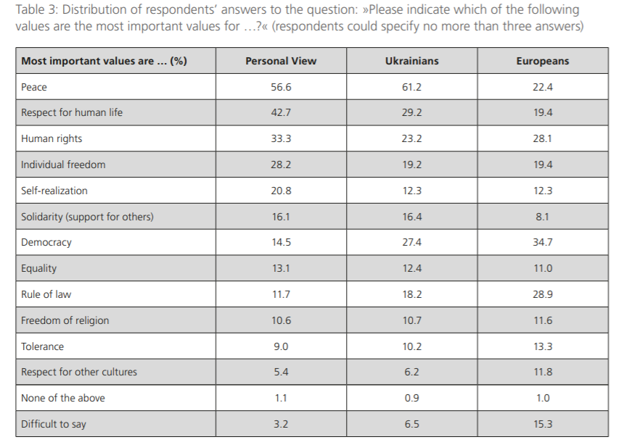
Source: Matthes Buhbe (ed.) 2017. How Ukrainians Perceive European Values Main Results of an Empirical Survey https://library.fes.de/pdf-files/id-moe/13731.pdf)
Questions for reflection:
- Compare different opinions about values. From your point of view, what is the reason for the different assessment of the importance of values for Ukrainians and Europeans?
- Do EU values coincide with European ones? Try to explain the difference in the materials of this case?
- What factors most influence the values of Ukrainians and Europeans? Why?
- Based on your own experience of European values, please identify their advantages and limitations.
- Please identify how values affect politics, the economy, the environment and society..
CASE-STUDY 3. WHAT EU VALUES DEPEND ON? VALUE SPACES.
Positioning different groups of voters within this value space not only allows us to understand the impact of values on political preferences but also the structural relationships between values and socio-demographics. For example, if we look at the position of groups defined by their educational levels in this value space, we see that there are virtually no differences between education groups in their economic values (as represented by the distance between them on the horizontal axis) but large differences on the liberal-authoritarian dimension (the vertical axis), with those with higher level qualifications being more liberal than those with lower level qualifications. In sharp contrast, comparing groups defined by household income we see the differences between groups are primarily along the economic value dimension (these groups spread out along the horizontal axis but are in broadly the same position on the vertical axis).
Additional information.
Liberalism is a political and moral philosophy based on liberty, consent of the governed and equality before the law. Liberals espouse a wide array of views depending on their understanding of these principles, but they generally support individual rights (including civil rights and human rights), democracy, secularism, freedom of speech, freedom of the press, freedom of religion and a market economy.
Authoritarianism is a form of government characterized by the rejection of political plurality, the use of strong central power to preserve the political status quo, and reductions in the rule of law, separation of powers, and democratic voting.
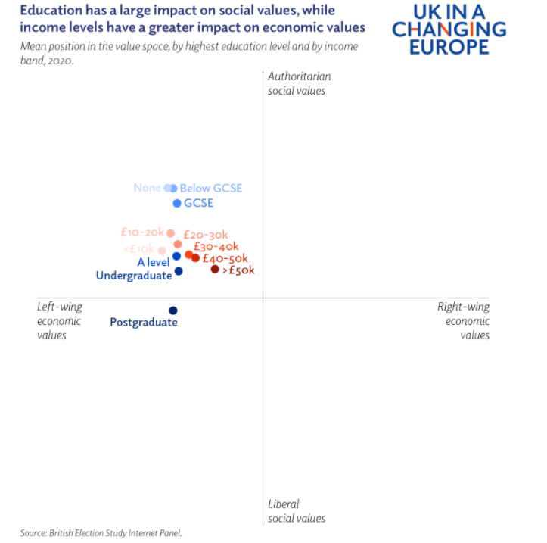
Source: Paula Surridge (2021). Brexit, British politics and values https://ukandeu.ac.uk/long-read/brexit-british-politics-and-values/
Questions for reflection:
- Why do citizens with higher income levels lean towards liberal social values?
- How can you specify the role of education in shaping the values of society?
- Do the data presented in the case correlate with the perception of values by your environment?
- What factors do you think can enhance the perception of liberal social values?

CASE-STUDY 4. TOLERANCE
The European Value Study shows that seventy percent of all Europeans want to teach their children tolerance and respect for other people. Sociologists also recognize tolerance as an important value in a free and open society: the more tolerant people are of the rights of others, the more secure are the rights of all. And tolerance undoubtedly promotes a peaceful coexistence between groups. However, tolerance is a ‘slippery’ term. In essence, being tolerant means that one accepts the way other people live their lives even when they do not agree with the others’ lifestyles. Tolerance shouldn’t be confused with simple indifference to what other people do, but it often is. Intolerance can be widely present within a society, but it is often kept silent and remains untested. Furthermore, tolerance is not an absolute value, there are proper limits to what should be tolerated. This results in the ‘paradox of tolerance’: a defense of tolerance may require some degree of intolerance.
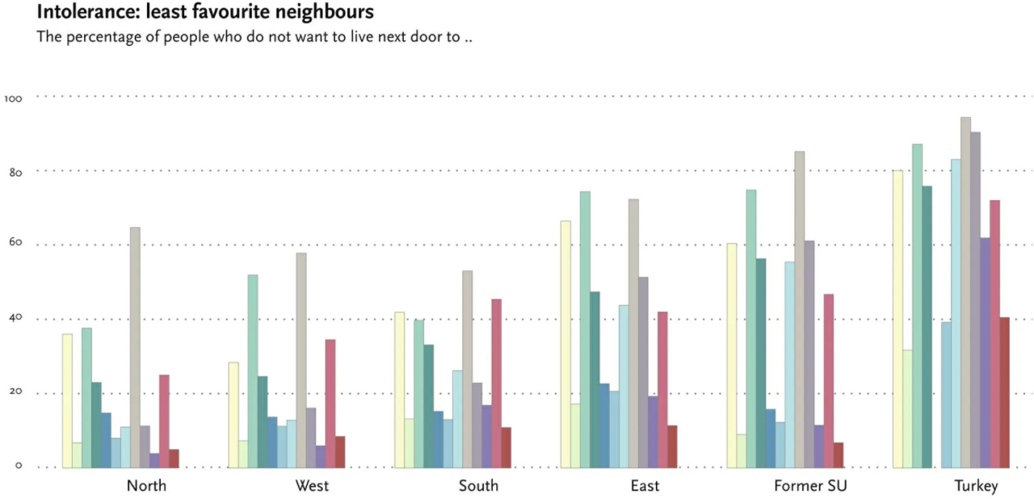
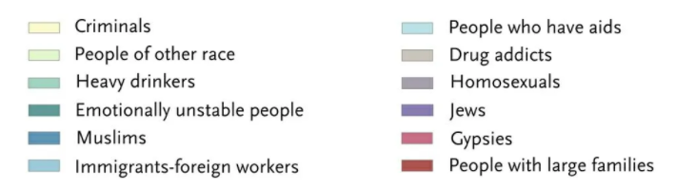
Source: https://europeanvaluesstudy.eu/about-evs/research-topics/society/
Questions for reflection:
- What causes different levels of tolerance for different parts of Europe / countries?
- Can we talk about one factor that determines the level of tolerance for all categories of categories? If so, justify which one? If not, justify why?
- To which category of "possible neighbours" is the highest level of tolerance is demonstrated? Why?
- Explain in the case materials how you understand the statement "defense of tolerance may require some degree of intolerance».

Foret, François,Calligaro, Oriane (2020). European values”. Challenges and opportunities for EU governance.
Paula Surridge (2021). Brexit, British politics and values https://ukandeu.ac.uk/long-read/brexit-british-politics-and-values/
https://www.europarl.europa.eu/news/en/press-room/20191209IPR68614/eurobarometer-protecting-human-rights-tops-citizens-list-of-eu-values

